**TOOLBOX TALK 9**

**SAFE STACKING**

Many accidents occur when materials have to be taken from stacks. In particular when this is done by hand.

Care taken when material is stacked initially can help prevent many of these.

**SAFE STACKS SAVE INJURIES**

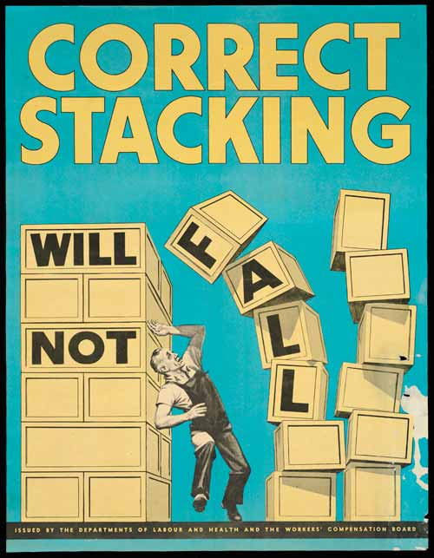

* When handling materials wear protective clothing, i.e. helmet, gloves and steel-toed boots.
* Only stack material in authorised areas, **NEVER** near doorways, access ways or on fire escape routes.
* Stack on a level surface and provide packing.
* Never make stacks higher than 3 times the minimum base width.
* When handling materials by hand, check weight, if in doubt **ASK.**

**Do not attempt to lift more than you feel able to**

**SHEET MATERIAL**

Stack flat where possible.

If stacked vertically, use suitable racks to prevent collapse - material stacked vertically against walls can collapse whilst being removed or may overload walls etc

**REMOVE IN REVERSE ORDER ONLY**

|  |  |  |  |  |
| --- | --- | --- | --- | --- |
| **Date** |  | | **Presented By** |  |
| **Time** |  | | **Project (If Applicable)** |  |
| Acknowledgement | I hereby acknowledge that I have received and understand the attached Toolbox Talk. I accept the responsibility of implementing it in my section and ensuring that all relevant line personnel within my area of responsibility are informed and comply accordingly. Any person relieving me or taking over my area of responsibility will also be informed accordingly by myself. | | | |
| **Name** | | **Surname** | | **Signature** |
|  | |  | |  |
|  | |  | |  |
|  | |  | |  |
|  | |  | |  |
|  | |  | |  |
|  | |  | |  |
|  | |  | |  |
|  | |  | |  |
|  | |  | |  |
|  | |  | |  |
|  | |  | |  |
|  | |  | |  |
|  | |  | |  |
|  | |  | |  |
|  | |  | |  |
|  | |  | |  |
|  | |  | |  |
|  | |  | |  |
|  | |  | |  |
|  | |  | |  |
|  | |  | |  |
|  | |  | |  |
|  | |  | |  |