**TOOLBOX TALK 8**

**MANUAL HANDLING OF EQUIPMENT**

* 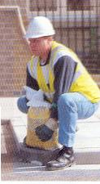Check the sign. Is it heavy bulky or unwieldy, difficult to grasp, unstable, or with contents likely to shift. Is it sharp, hot or otherwise potentially damaging?
* Where possible gloves should be worn to protect against cuts, scratches or punctures wounds.
* Wear safety boots or shoes to protect toes from falling loads.
* Size up the load and if necessary, make a trial lift of a few inches.
* Do not attempt to lift alone any load that is too heavy, too large or awkward.
* Is there a lack of space, which will prevent good posture? See that there are no obstructions, uneven, slippery, and unstable or variations in the levels of floors or work surfaces in the direction you will be going.
* Take up lifting position, feet about hip breadth apart, one foot slightly in front of the other pointing in direction you are intending to move.
* Bend the knees, back muscles should be relaxed.
* Get a secure grip of the sign.
* Lift, keeping the back straight, arms close to body, chin in head up, leg muscles taking the strain.
* Step off in the direction the advanced foot is pointing, sign held close to the body.
* 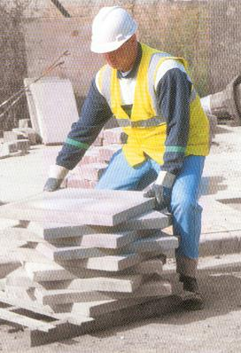Do not carry a sign, which obscures your vision.
* When lifting to a height from the floor do it in two stages if possible.
* Where possible get some to give you a hand to half the load.

**LOOK AFTER YOUR BACK!!**

|  |  |  |  |  |
| --- | --- | --- | --- | --- |
| **Date** |  | | **Presented By** |  |
| **Time** |  | | **Project (If Applicable)** |  |
| Acknowledgement | I hereby acknowledge that I have received and understand the attached Toolbox Talk. I accept the responsibility of implementing it in my section and ensuring that all relevant line personnel within my area of responsibility are informed and comply accordingly. Any person relieving me or taking over my area of responsibility will also be informed accordingly by myself. | | | |
| **Name** | | **Surname** | | **Signature** |
|  | |  | |  |
|  | |  | |  |
|  | |  | |  |
|  | |  | |  |
|  | |  | |  |
|  | |  | |  |
|  | |  | |  |
|  | |  | |  |
|  | |  | |  |
|  | |  | |  |
|  | |  | |  |
|  | |  | |  |
|  | |  | |  |
|  | |  | |  |
|  | |  | |  |
|  | |  | |  |
|  | |  | |  |
|  | |  | |  |
|  | |  | |  |
|  | |  | |  |
|  | |  | |  |
|  | |  | |  |
|  | |  | |  |