**TOOLBOX TALK 7**

**FIRE**

* Ensure that you know what steps to take in the event of a fire and the assembly point to report to.
* Familiarise yourself with the escape routes.
* Keep fire doors, shutters and escape routes clear and unobstructed.
* Do not obstruct access to fire extinguishers; learn how they operate - read the labels or ask. The use of fire extinguishers should form part of your safety induction.
* If you attempt to extinguish a fire do not put yourself at risk.
* Do not let paper, oil rags or other rubbish and materials accumulate.
* Do not smoke in forbidden areas.
* Use proper containers for flammable liquids, not open tins or buckets.
* Handle flammable liquids at a safe distance from possible sources of ignition.
* Ensure you have a fire extinguisher close by at all times.
* Switch off from the mains any electrical equipment when not in use.

**PLAN IN ADVANCE**

**YOU WILL NOT HAVE TIME WHEN FIRE BREAKS OUT**

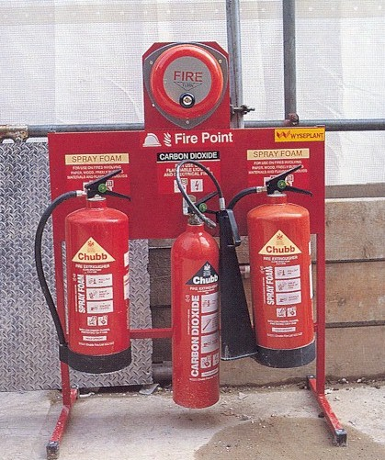

|  |  |  |  |  |
| --- | --- | --- | --- | --- |
| **Date** |  | | **Presented By** |  |
| **Time** |  | | **Project (If Applicable)** |  |
| Acknowledgement | I hereby acknowledge that I have received and understand the attached Toolbox Talk. I accept the responsibility of implementing it in my section and ensuring that all relevant line personnel within my area of responsibility are informed and comply accordingly. Any person relieving me or taking over my area of responsibility will also be informed accordingly by myself. | | | |
| **Name** | | **Surname** | | **Signature** |
|  | |  | |  |
|  | |  | |  |
|  | |  | |  |
|  | |  | |  |
|  | |  | |  |
|  | |  | |  |
|  | |  | |  |
|  | |  | |  |
|  | |  | |  |
|  | |  | |  |
|  | |  | |  |
|  | |  | |  |
|  | |  | |  |
|  | |  | |  |
|  | |  | |  |
|  | |  | |  |
|  | |  | |  |
|  | |  | |  |
|  | |  | |  |
|  | |  | |  |
|  | |  | |  |
|  | |  | |  |
|  | |  | |  |