**TOOLBOX TALK 5**

**HEAD SAFETY**

By wearing the correct headwear you can help prevent, much discomfort, many injuries and even **DEATH.**

**Safety Helmets**

* Every year in the construction industry 140-head injuries are reported to the Health and Safety Executive. These are only the most serious cases, 50% are fractures of the head, many more are never reported, yet still cause much pain and suffering.
* In the last 2 years safety helmets have saved at least 3 men’s lives - **YOURS MAY BE NEXT.**
* Wearing a safety helmet can prevent most head injuries.
* Safety helmets are designed to a British Standard to be strong enough to prevent most falling materials damaging your brain. If your brain is damaged it is unlikely that you will be able to work as well as now.
* Helmets can also prevent many of the minor head injuries from bumps and scrapes that occur on sites.
* It is OK to customise your helmets by sticking labels or ‘go faster stripes’ on them but do not modify the shell or harness by cutting or drilling, as this weakens the overall effect. Some spray paints also weaken the shell so unless you are certain do not use spray or cellulose paint.

**REMEMBER YOUR LIFE MAY DEPEND ON IT**

**WEAR YOUR GEAR WITH PRIDE**

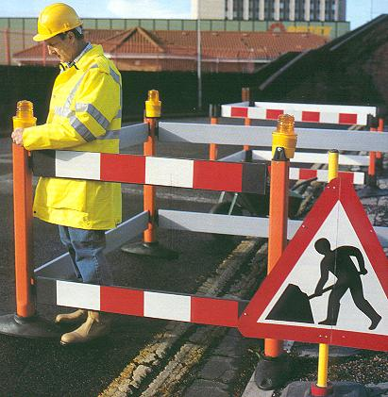

|  |  |  |  |  |
| --- | --- | --- | --- | --- |
| **Date** |  | | **Presented By** |  |
| **Time** |  | | **Project (If Applicable)** |  |
| Acknowledgement | I hereby acknowledge that I have received and understand the attached Toolbox Talk. I accept the responsibility of implementing it in my section and ensuring that all relevant line personnel within my area of responsibility are informed and comply accordingly. Any person relieving me or taking over my area of responsibility will also be informed accordingly by myself. | | | |
| **Name** | | **Surname** | | **Signature** |
|  | |  | |  |
|  | |  | |  |
|  | |  | |  |
|  | |  | |  |
|  | |  | |  |
|  | |  | |  |
|  | |  | |  |
|  | |  | |  |
|  | |  | |  |
|  | |  | |  |
|  | |  | |  |
|  | |  | |  |
|  | |  | |  |
|  | |  | |  |
|  | |  | |  |
|  | |  | |  |
|  | |  | |  |
|  | |  | |  |
|  | |  | |  |
|  | |  | |  |
|  | |  | |  |
|  | |  | |  |
|  | |  | |  |