**TOOLBOX TALK 4**

**EYE PROTECTION**

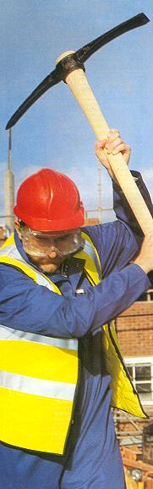

* A tiny fragment in your eye can cause disaster.
* Trained first-aid for attention to eyes - not a dirty handkerchief.
* You have a legal obligation to wear or use the eye protection provided in accordance with regulations.
* Even if you are not carrying out one of the specified processes you may be at risk, so wear or use the eye protection provided.
* Do not go into areas where eye protection is required unless you are wearing protective equipment.
* Take care of any protective equipment issued to you.
* Have any damaged, lost or unserviceable protective equipment replaced immediately.
* Make sure your eye protectors are suitable for you and for the work being done.
* Ensure that eye protectors are comfortable to wear and keep them clean.
* The place for eye protectors is over your eyes - not on your head or round your neck.

**REMEMBER** - eye protectors are replaceable; your eyes are not.

|  |  |  |  |  |
| --- | --- | --- | --- | --- |
| **Date** |  | | **Presented By** |  |
| **Time** |  | | **Project (If Applicable)** |  |
| Acknowledgement | I hereby acknowledge that I have received and understand the attached Toolbox Talk. I accept the responsibility of implementing it in my section and ensuring that all relevant line personnel within my area of responsibility are informed and comply accordingly. Any person relieving me or taking over my area of responsibility will also be informed accordingly by myself. | | | |
| **Name** | | **Surname** | | **Signature** |
|  | |  | |  |
|  | |  | |  |
|  | |  | |  |
|  | |  | |  |
|  | |  | |  |
|  | |  | |  |
|  | |  | |  |
|  | |  | |  |
|  | |  | |  |
|  | |  | |  |
|  | |  | |  |
|  | |  | |  |
|  | |  | |  |
|  | |  | |  |
|  | |  | |  |
|  | |  | |  |
|  | |  | |  |
|  | |  | |  |
|  | |  | |  |
|  | |  | |  |
|  | |  | |  |
|  | |  | |  |
|  | |  | |  |