**TOOLBOX TALK 3**

**WORKING DRESS**

* Wear the right clothing for the job.

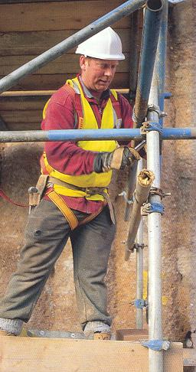

* Always keep clothes clean. Dirty clothes can offer a

fire or dermatitis risk.

* Avoid loose ends. The old school tie can throttle you.
* If protective clothing is provided, wear it.
* Gloves will protect your hands.
* A safety helmet will protect your head and perhaps

save your life.

* Safety shoes save toes.
* Danger can strike upwards. Be sure your boots or

shoes have strong soles.

* Remove contaminated clothing immediately and **WASH.**
* **REMEMBER,** cotton burns easier than wool.

**Scaffolder wearing PPE including a safety harness attached back to the structure.**

* It is worth dressing properly, even for a short job.
* Hi Viz. clothing makes you more visible to drivers.

#### PROPER CLOTHING MEANS SAFER WORKING

|  |  |  |  |  |
| --- | --- | --- | --- | --- |
| **Date** |  | | **Presented By** |  |
| **Time** |  | | **Project (If Applicable)** |  |
| Acknowledgement | I hereby acknowledge that I have received and understand the attached Toolbox Talk. I accept the responsibility of implementing it in my section and ensuring that all relevant line personnel within my area of responsibility are informed and comply accordingly. Any person relieving me or taking over my area of responsibility will also be informed accordingly by myself. | | | |
| **Name** | | **Surname** | | **Signature** |
|  | |  | |  |
|  | |  | |  |
|  | |  | |  |
|  | |  | |  |
|  | |  | |  |
|  | |  | |  |
|  | |  | |  |
|  | |  | |  |
|  | |  | |  |
|  | |  | |  |
|  | |  | |  |
|  | |  | |  |
|  | |  | |  |
|  | |  | |  |
|  | |  | |  |
|  | |  | |  |
|  | |  | |  |
|  | |  | |  |
|  | |  | |  |
|  | |  | |  |
|  | |  | |  |
|  | |  | |  |
|  | |  | |  |