**TOOLBOX TALK 2**

**PERSONAL POINTS**

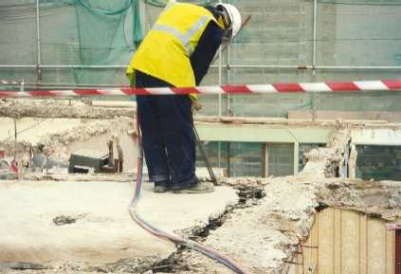

* Do not take chances - carry out instructions.
* If you do not know - ask.
* Rectify or report all unsafe conditions.
* Use correct tools and equipment.
* Help to keep the work place clean and tidy.
* Have all injuries, however slight, properly

attended to and entered into the accident book.

**Is this safe?**

* Do not horseplay or distract others.
* Wear the protective clothing and equipment provided for your safety.

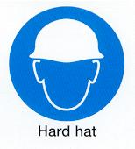

* Obey all safety rules and signs.
* Use only those tools you are authorised to use.
* Do not leave tools on the floor or where they can fall

on people below.

* Familiarise yourself with the fire/ emergency procedures.
* Be aware of others working in your area. Does the task

you are undertaking create a safety risk to others.

Do not forget those who maybe be working below you.

* Are you at Risk from the activities of others? Inform your supervisor so that the works can be co-ordinated safely.

**YOU MAY BE ALL RIGHT BUT THINK OF YOUR MATES**

|  |  |  |  |  |
| --- | --- | --- | --- | --- |
| **Date** |  | | **Presented By** |  |
| **Time** |  | | **Project (If Applicable)** |  |
| Acknowledgement | I hereby acknowledge that I have received and understand the attached Toolbox Talk. I accept the responsibility of implementing it in my section and ensuring that all relevant line personnel within my area of responsibility are informed and comply accordingly. Any person relieving me or taking over my area of responsibility will also be informed accordingly by myself. | | | |
| **Name** | | **Surname** | | **Signature** |
|  | |  | |  |
|  | |  | |  |
|  | |  | |  |
|  | |  | |  |
|  | |  | |  |
|  | |  | |  |
|  | |  | |  |
|  | |  | |  |
|  | |  | |  |
|  | |  | |  |
|  | |  | |  |
|  | |  | |  |
|  | |  | |  |
|  | |  | |  |
|  | |  | |  |
|  | |  | |  |
|  | |  | |  |
|  | |  | |  |
|  | |  | |  |
|  | |  | |  |
|  | |  | |  |
|  | |  | |  |
|  | |  | |  |