**TOOLBOX TALK 19**

**WORKING AT HEIGHTS**

Common cases include falls from scaffolding, ladders and through fragile surfaces. 'Working at Height' means work in any place where, if there were no precautions in place, a person could fall a distance liable to cause personal injury or even death

Golden Rules

1. Use Rails – where you can
2. Select the proper PPE.
3. Inspect your PPE.
4. Ensure you understand fall distance.
5. Ensure the selection of acceptable anchor point.
6. Ensure you select the best means of working at heights (Scaffold vs Lift vs ladder)
7. Use ladders properly.
8. Know your procedures and height limits.
9. Ensure you are trained and competent.

What is a safety harness - Safety harness. ... The harness is an attachment between a stationary and non-stationary object and is usually fabricated from rope, cable or webbing and locking hardware. Some safety harnesses are used in combination with a shock absorber, which is used to regulate deceleration when the end of the rope is reached.

How to use a safety harness.

1. Check that the harness is in good condition.

2. Secure shoulder strap to waist belt. Shoulder strap must be between two leg straps.

3. Secure leg straps to waist belt.

4. Put legs through rings of leg straps and fit belt to waist.

5. Adjust rings of leg straps to fit properly around leg.

6. Put front loop of shoulder straps through waist belt.

7. Adjust shoulder straps to fit properly.

8. Ensure harness fits comfortably.

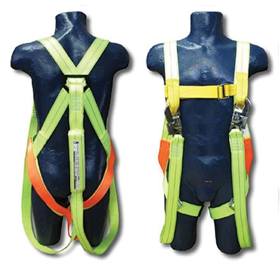

|  |  |  |  |  |
| --- | --- | --- | --- | --- |
| **Date** |  | | **Presented By** |  |
| **Time** |  | | **Project (If Applicable)** |  |
| Acknowledgement | I hereby acknowledge that I have received and understand the attached Toolbox Talk. I accept the responsibility of implementing it in my section and ensuring that all relevant line personnel within my area of responsibility are informed and comply accordingly. Any person relieving me or taking over my area of responsibility will also be informed accordingly by myself. | | | |
| **Name** | | **Surname** | | **Signature** |
|  | |  | |  |
|  | |  | |  |
|  | |  | |  |
|  | |  | |  |
|  | |  | |  |
|  | |  | |  |
|  | |  | |  |
|  | |  | |  |
|  | |  | |  |
|  | |  | |  |
|  | |  | |  |
|  | |  | |  |
|  | |  | |  |
|  | |  | |  |
|  | |  | |  |
|  | |  | |  |
|  | |  | |  |
|  | |  | |  |
|  | |  | |  |
|  | |  | |  |
|  | |  | |  |
|  | |  | |  |
|  | |  | |  |