**TOOLBOX TALK 17**

**USE OF FIRE EXTINGUISHERS**

|  |  |
| --- | --- |
| **TYPE OF FIRE EXTINGUISHER** | **SUITABLE ON THE FOLLOWING TYPES OF FIRES** |
| **WATER**  (Painted Red) | For use on type A fires which is combustible solids, timbers, plastics. |
| **FOAM**  (Painted red with a cream stripe) | For use on flammable liquids. |
| **TRI-CLASS FOAM**  (Painted red with a cream stripe) | For use on all types of fires except electrical. |
| **CARBON DIOXIDE (C02)**  (Painted red **with a black stripe)** | Suitable for use on all electrical type fires, computers, heaters, distribution boards and transformers. |
| **DRY POWDER**  (Painted red with a blue stripe) | Suitable for fires involving flammable liquids or electrical apparatus. |

**Use of Extinguishers Normally Found**

* Select the correct fire extinguisher for the type of fire.
* Read the instructions on the side of the extinguisher.
* Remove the safety pin to activate and squeeze hard to release extinguishing agent. The flow can be controlled by this handle.
* Take a position where access to the fire is unrestricted but where a safe and quick retreat is possible e.g. near an exit, or when outside, windward of the fire. This is extremely important.
* Crouching will help the operator to keep clear of smoke, avoid heat and allow a closer approach to the fire.

**Foam**

* With foam, do not aim the jet directly at the liquid because this will drive the foam beneath the surface and render it ineffective. It may also cause the fire to spread. With tri-class foam, for use on combustible solids, timber, paper, etc. aim the foam jet at the base of the fire.
* 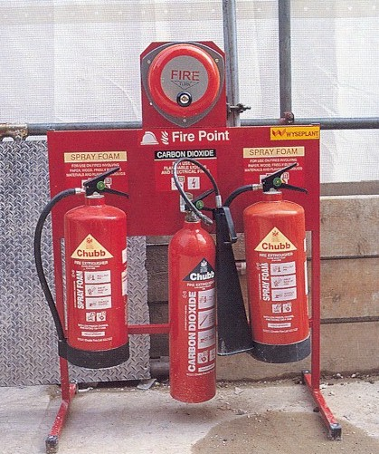Aim the jet at a vertical surface behind the fire above the level of the fire, this breaks up the jet and allows the foam to build up over the top of the fire.
* Where this is not possible, stand well back and direct the jet with a sweeping movement allowing the foam to drop down on the surface of the fire. The average length of the jet from a foam extinguisher is 7m.

Do not use a fire extinguisher to put out a fire involving

burning gas.. Turn off the supply if it is safe to do so and

leave to the fire brigade.

.

|  |  |  |  |  |
| --- | --- | --- | --- | --- |
| **Date** |  | | **Presented By** |  |
| **Time** |  | | **Project (If Applicable)** |  |
| Acknowledgement | I hereby acknowledge that I have received and understand the attached Toolbox Talk. I accept the responsibility of implementing it in my section and ensuring that all relevant line personnel within my area of responsibility are informed and comply accordingly. Any person relieving me or taking over my area of responsibility will also be informed accordingly by myself. | | | |
| **Name** | | **Surname** | | **Signature** |
|  | |  | |  |
|  | |  | |  |
|  | |  | |  |
|  | |  | |  |
|  | |  | |  |
|  | |  | |  |
|  | |  | |  |
|  | |  | |  |
|  | |  | |  |
|  | |  | |  |
|  | |  | |  |
|  | |  | |  |
|  | |  | |  |
|  | |  | |  |
|  | |  | |  |
|  | |  | |  |
|  | |  | |  |
|  | |  | |  |
|  | |  | |  |
|  | |  | |  |
|  | |  | |  |
|  | |  | |  |
|  | |  | |  |