**TOOLBOX TALK 16**

**OPENINGS AND EDGES**

Every year in our industry hundreds of people are killed or injured when they fall from an unprotected area or are struck by materials or tools falling from above.

The **LAW** requires that if you work where it is possible for you to fall more than 2 metres, then protection must be provided.

The following list gives an idea of the required protection:-

**Scaffolds**

Double Guardrails and toe-boards must be provided to all working levels, also secured ladders are required.

**Floors**

Protection must be provided to all floor edges, lift openings, stairways and duct openings.

If you remove protection under instruction make sure it is replaced.

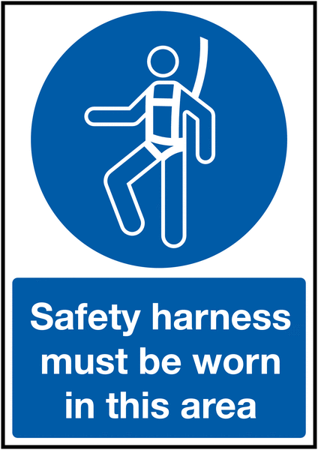Where edge protection is not practical, safety harnesses and restraint wire may be suitable.

|  |  |  |  |  |
| --- | --- | --- | --- | --- |
| **Date** |  | | **Presented By** |  |
| **Time** |  | | **Project (If Applicable)** |  |
| Acknowledgement | I hereby acknowledge that I have received and understand the attached Toolbox Talk. I accept the responsibility of implementing it in my section and ensuring that all relevant line personnel within my area of responsibility are informed and comply accordingly. Any person relieving me or taking over my area of responsibility will also be informed accordingly by myself. | | | |
| **Name** | | **Surname** | | **Signature** |
|  | |  | |  |
|  | |  | |  |
|  | |  | |  |
|  | |  | |  |
|  | |  | |  |
|  | |  | |  |
|  | |  | |  |
|  | |  | |  |
|  | |  | |  |
|  | |  | |  |
|  | |  | |  |
|  | |  | |  |
|  | |  | |  |
|  | |  | |  |
|  | |  | |  |
|  | |  | |  |
|  | |  | |  |
|  | |  | |  |
|  | |  | |  |
|  | |  | |  |
|  | |  | |  |
|  | |  | |  |
|  | |  | |  |