**TOOLBOX TALK 14**

**TOWER SCAFFOLDS**

All tower scaffolds must:-

* Be erected in accordance with the manufactures instructions by competent operatives. The erection instructions must be available on site.
* All components must be checked before they are used to ensure they are in good condition. Check wheels for effective rotation and brake and locking device work correctly.
* Towers must only be used on firm surfaces, where the ground is soft or sloping adequate support must be provided.
* The platform height should not be more than 3 times the shortest side of the tower. (Example: shortest side of a tower = 1.5m multiplied by 3, giving a maximum platform height of 4.5m). This height can be increased by the use of outriggers.
* Working platforms must be fitted with double guardrails and toe boards.
* Care must be taken when working from the platform that pulling or pushing actions do not overturn the tower. Do not climb the outside of the tower.
* Do not pull heavy items up the side of the tower, use lifting devices. Always check the manufactures information for the safe working load and do not exceed it.
* Do not use ladders from platforms of towers as this causes high overturning forces.
* Towers to be inspected before use and if erected for more than a week, results of inspection recorded.

**Access to tower scaffolds**

Proprietary steel or aluminium towers have a variety of means of access, these being:-

* Integral diagonal stairway. As well as providing access this will form part of the bracing of the tower.
* Ladder units which slip onto the end frame or inclined ladders, securely fixed, inside the scaffold frame.
* Climbing a ladder section which is incorporated within the end frame. Such a ladder section will have rungs no more than 300mm apart with stiles no more than 480mm apart. Climbing horizontal members of other types of end frame is not accepted as a safe means of access.

**Working platforms must have:-**

* Trap doors to enable access from the inside of the tower.
* A minimum platform width of 600mm.
* 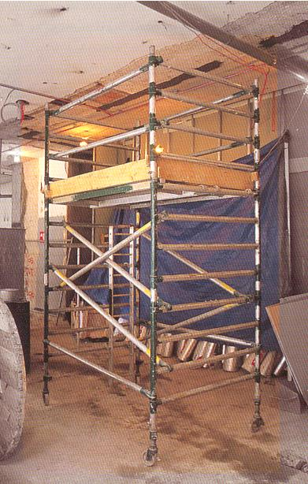Double guardrails and toe boards. (Toe board minimum 150mm high, with gaps between toe board and guard rails not exceeding 470mm) obviously

**Wheels in locked position**

**Double handrail and toe board**

**Internal access**

**ladder**

**Wheels in locked position**

|  |  |  |  |  |
| --- | --- | --- | --- | --- |
| **Date** |  | | **Presented By** |  |
| **Time** |  | | **Project (If Applicable)** |  |
| Acknowledgement | I hereby acknowledge that I have received and understand the attached Toolbox Talk. I accept the responsibility of implementing it in my section and ensuring that all relevant line personnel within my area of responsibility are informed and comply accordingly. Any person relieving me or taking over my area of responsibility will also be informed accordingly by myself. | | | |
| **Name** | | **Surname** | | **Signature** |
|  | |  | |  |
|  | |  | |  |
|  | |  | |  |
|  | |  | |  |
|  | |  | |  |
|  | |  | |  |
|  | |  | |  |
|  | |  | |  |
|  | |  | |  |
|  | |  | |  |
|  | |  | |  |
|  | |  | |  |
|  | |  | |  |
|  | |  | |  |
|  | |  | |  |
|  | |  | |  |
|  | |  | |  |
|  | |  | |  |
|  | |  | |  |
|  | |  | |  |
|  | |  | |  |
|  | |  | |  |
|  | |  | |  |