**TOOLBOX TALK 12**

**THE SAFE USE OF LADDERS**

***Why Do People Fall From Ladders?***

A recent study of 433 falls from fixed and portable ladders disclosed:-

277 cases where the ladder slipped. 180 cases where the ladder remained stable, 24 cases where there was a structural defect in the ladder or its anchorage, 2 cases where the ladder was struck by a vehicle.

The dominating factors where a ladder remained stable were:-

81 Foot slipped on rung 36 Carrying tools or materials

18 Missed footing 5 Obstruction part way up ladder

5 Lost footing 2 Struck by falling material

14 Overbalanced 7 Jumped off to avoid hazards

12 Overreached

***What Can Be Done to Reduce the Risk?***

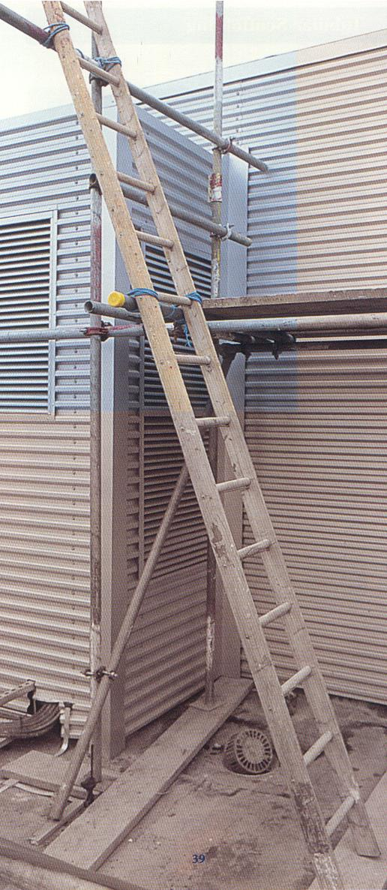

* See that the ladder cannot slip.
* Ensure ladders are tied near the top.
* Keep rungs and footwear clean.
* Use both hands when climbing or descending.
* Ladders staked to prevent slipping outwards and sideways.
* Set ladders at the correct angle 300mm out to every 1.200mm up.
* Always check ladders before and after use,

report any defects immediately.

* Never use a make shift ladder.
* Do not use ladders with cracked or broken rungs or other defects.
* Do not over reach from a ladder - always move it.
* Do not stand a ladder on a drum, box or other unsteady base.
* Never overload a ladder or support it on its bottom rung on a plank.
* Do not use ladders that are too short.

**LADDER SET AT THE CORRECT ANGLE AND FIRMLY SECURED**

|  |  |  |  |  |
| --- | --- | --- | --- | --- |
| **Date** |  | | **Presented By** |  |
| **Time** |  | | **Project (If Applicable)** |  |
| Acknowledgement | I hereby acknowledge that I have received and understand the attached Toolbox Talk. I accept the responsibility of implementing it in my section and ensuring that all relevant line personnel within my area of responsibility are informed and comply accordingly. Any person relieving me or taking over my area of responsibility will also be informed accordingly by myself. | | | |
| **Name** | | **Surname** | | **Signature** |
|  | |  | |  |
|  | |  | |  |
|  | |  | |  |
|  | |  | |  |
|  | |  | |  |
|  | |  | |  |
|  | |  | |  |
|  | |  | |  |
|  | |  | |  |
|  | |  | |  |
|  | |  | |  |
|  | |  | |  |
|  | |  | |  |
|  | |  | |  |
|  | |  | |  |
|  | |  | |  |
|  | |  | |  |
|  | |  | |  |
|  | |  | |  |
|  | |  | |  |
|  | |  | |  |
|  | |  | |  |
|  | |  | |  |