**TOOLBOX TALK 11**

**WORKING SAFELY WITH ELECTRICITY**

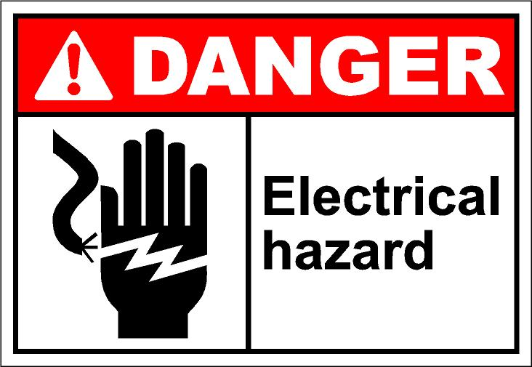There is a very tragic way to learn about the dangers of misusing electrical tools and equipment - it is called **electrocution.**

Electricity is part of our modern way of life, pushing in a plug becomes second nature and all items of electrical equipment are produced to strict safety standards, so to all intents and purposes, used correctly, they **ARE** safe. Why then do so many people suffer shocks? Everyone knows electricity can and does **KILL** and still people continue to take stupid risks with it **OR** they take it for granted where safety is concerned - both of which can lead to shock, burns, serious injury or even a horrible death!!

The dangers are particularly increased at work - where electrical equipment is used in adverse conditions, on site in wet or damp areas for instance or where voltages are necessarily more lethal.

Read this guide, follow these simple safety rules in your working situation and if in doubt about the safety of an electrical equipment - report it, get an electrician or the proper maintenance people for the job **IMMEDIATELY**!! Do not let a live take a life - yours, or anyone else’s.

**A**lways check for defective plugs, cables and sockets before using any electrical equipment!!

**B**e sure that cables are long enough to reach your working place without straining or pulling!!

**C**orrect power supply is important for all equipment - check that it is adequate!!

**D**isconnection from the mains supply is important for all equipment maintenance work.

**F**uses should always be appropriate to the equipment to which they are fitted!!

**G**et all blown fuses replaced promptly and correctly. Never ‘**MAKE DO’!!**

**I**nstallation of all electrical wiring requires the attention of a qualified contractor!!

**J**oined lengths of cable should always be attached by the proper connections and **NEVER** with insulating tape!!

**P**ortable power tools must never be used near flammable vapours or gases!!

**Q**ualified help should be sought immediately on **ALL** types of electrical problems!! Never touch or tamper yourself!!

**R**eport all defective tools and equipment!!

**U**nder no circumstances should you touch plugs, sockets or electrical equipment with wet hands!!

**W**ater should be kept away from all electrical equipment and tools should not be used in wet or damp conditions!!

|  |  |  |  |  |
| --- | --- | --- | --- | --- |
| **Date** |  | | **Presented By** |  |
| **Time** |  | | **Project (If Applicable)** |  |
| Acknowledgement | I hereby acknowledge that I have received and understand the attached Toolbox Talk. I accept the responsibility of implementing it in my section and ensuring that all relevant line personnel within my area of responsibility are informed and comply accordingly. Any person relieving me or taking over my area of responsibility will also be informed accordingly by myself. | | | |
| **Name** | | **Surname** | | **Signature** |
|  | |  | |  |
|  | |  | |  |
|  | |  | |  |
|  | |  | |  |
|  | |  | |  |
|  | |  | |  |
|  | |  | |  |
|  | |  | |  |
|  | |  | |  |
|  | |  | |  |
|  | |  | |  |
|  | |  | |  |
|  | |  | |  |
|  | |  | |  |
|  | |  | |  |
|  | |  | |  |
|  | |  | |  |
|  | |  | |  |
|  | |  | |  |
|  | |  | |  |
|  | |  | |  |
|  | |  | |  |
|  | |  | |  |