**TOOLBOX TALK 10**

**HAND TOOLS**

* Use the right size spanner for the nut. Where adjustable spanners are used take extra care as these slip more easily.
* Files must be fitted with handles to prevent hand injuries and files must not be used as punches or for levering as they break easily.
* Keep hammer heads tightly wedged on their shafts.
* Replace split or damaged wooden handles, do not wire or tape up.
* Keep edges of cutting tools sharp.
* Do not use screwdrivers on work held in the hand.
* Do not use screwdrivers as chisels - handles fracture.
* Keep tools in racks or boxes when not in use.
* Protect sharp edges of tools that are to be stored or covered, Stanley Knives kept in pockets uncovered cause many hand injuries.
* Scrap tools when they become worn or damaged beyond repair.
* Always use the correct tool for the job. Do not improvise.

**GOOD TOOLS MEAN FASTER AND SAFER WORK**

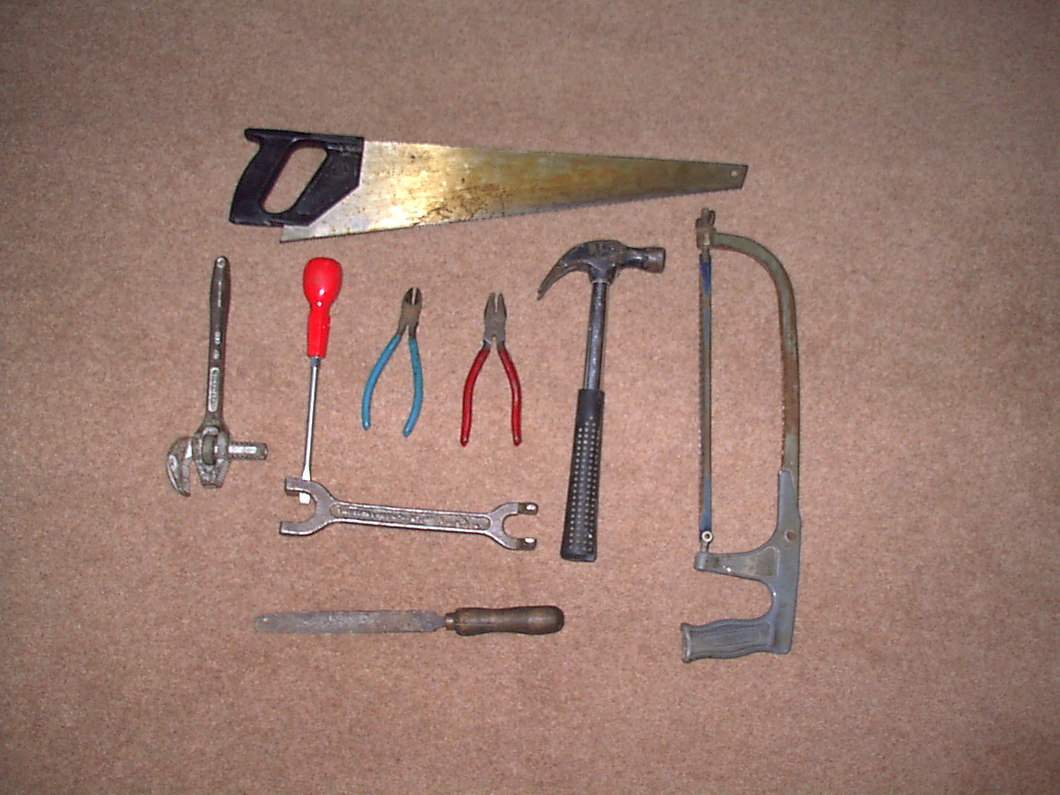

|  |  |  |  |  |
| --- | --- | --- | --- | --- |
| **Date** |  | | **Presented By** |  |
| **Time** |  | | **Project (If Applicable)** |  |
| Acknowledgement | I hereby acknowledge that I have received and understand the attached Toolbox Talk. I accept the responsibility of implementing it in my section and ensuring that all relevant line personnel within my area of responsibility are informed and comply accordingly. Any person relieving me or taking over my area of responsibility will also be informed accordingly by myself. | | | |
| **Name** | | **Surname** | | **Signature** |
|  | |  | |  |
|  | |  | |  |
|  | |  | |  |
|  | |  | |  |
|  | |  | |  |
|  | |  | |  |
|  | |  | |  |
|  | |  | |  |
|  | |  | |  |
|  | |  | |  |
|  | |  | |  |
|  | |  | |  |
|  | |  | |  |
|  | |  | |  |
|  | |  | |  |
|  | |  | |  |
|  | |  | |  |
|  | |  | |  |
|  | |  | |  |
|  | |  | |  |
|  | |  | |  |
|  | |  | |  |
|  | |  | |  |