**TOOLBOX TALK 1**

**HOUSEKEEPING**

Poor housekeeping results in accidents.

**Photograph showing:**

* Rubbish left lying around
* Blocked access way
* Unstable stacked material

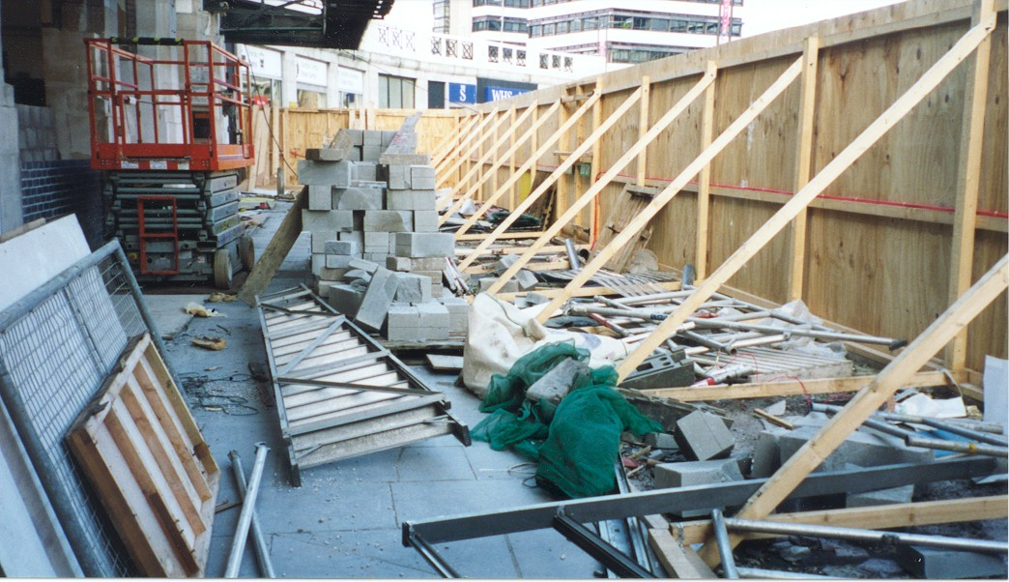

Good housekeeping at work has the same importance as in the home.

Do not rely on others to put things away - they won’t.

It’s just as easy to put tools away tidily as it is to leave them lying around on benches, on the floor, on scaffolding, resting on pipes or other positions where they could create a tripping hazard, fall onto a person, or be damaged in a fall.

You will also be able to find them when you next need them.

**REMEMBER – A place for everything and everything in its place.**

**REMEMBER – Rubbish left lying around is also a trip hazard to the person following you.**

|  |  |  |  |  |
| --- | --- | --- | --- | --- |
| **Date** |  | | **Presented By** |  |
| **Time** |  | | **Project (If Applicable)** |  |
| Acknowledgement | I hereby acknowledge that I have received and understand the attached Toolbox Talk. I accept the responsibility of implementing it in my section and ensuring that all relevant line personnel within my area of responsibility are informed and comply accordingly. Any person relieving me or taking over my area of responsibility will also be informed accordingly by myself. | | | |
| **Name** | | **Surname** | | **Signature** |
|  | |  | |  |
|  | |  | |  |
|  | |  | |  |
|  | |  | |  |
|  | |  | |  |
|  | |  | |  |
|  | |  | |  |
|  | |  | |  |
|  | |  | |  |
|  | |  | |  |
|  | |  | |  |
|  | |  | |  |
|  | |  | |  |
|  | |  | |  |
|  | |  | |  |
|  | |  | |  |
|  | |  | |  |
|  | |  | |  |
|  | |  | |  |
|  | |  | |  |
|  | |  | |  |
|  | |  | |  |
|  | |  | |  |