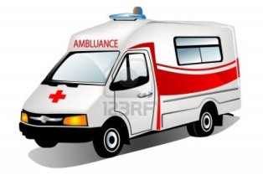 | AMBULANCE
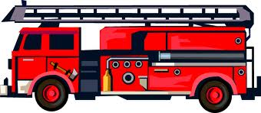 | FIRE DEPARTMENT
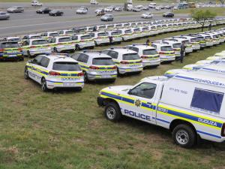 | POLICE | 10111
 | HOSPITAL / CLINIC
 | CLIENT
Designation | Name and Surname | Contact Number
Manager
Supervisor
First Aider
HSE Rep’s

